Meeting moments

11/13/2019

1. What I’ve been doing?
   1. Learning R
   2. Reading textual analysis literature
   3. Replicating some textual analysis paper: tetlock (2007)
2. How do you think about the proposal?

TFM: Debt contracting: relationship lending; more specific point

What is conservatism in texts: Reading 10-ks; Industry with bloated B/S?

11/26/2019: CONS+CSR/CONS+TXA/TXA+traits

1. I did not start to read corporate fillings (10-Ks or earnings press releases) because I don’t want to go to details without a specific goal (how is a corporate disclosure conservative <- what is conservatism <- conditional or unconditional), so I first went to read some survey papers on CONS and TXA.
2. Read:

CONS

Penalva and Wagenhofer (2019) and Giner and Mora (2019) (BOOK)

TXA

Li (2010), Loughran and McDonald (2016), Kravet and Muslu (2013) – risk disclosure

NARRATIVE CONS.

1. Reading textual processing books, replicate some papers using dictionaries or statistical methods.
2. Reading corporate fillings, to see how firms disclose risk. Timeliness of bad news (industry shock, more or less good/bad future events discussion) recognition.

Conditional on that I know a good and a bad news will realize in the same day in the future, if in my start to discuss the bad news somedays earlier than good news in my financial report, then I am being conditional conservative in narratives.

Unconditional conservatism:

Very bad firms, something bad has happened in their time series

CONS_CSR

1. Does constituency increase CSR? YES
2. Does CSR increase conservatism? YES
3. Logit chain: CSR increase -> more consideration on debtholder interests -> less riskier investments [standard deviation of stock returns] -> 1. less lender monitoring 2. more conservatism -> Lower cost of debt
   1. AFB
   2. BASU
4. Why?
   1. for which kind of firms is this increase significant (high/low existing debt, with high/low debt-contracting demand, managerial ability, risk)
   2. rationale: debtholders demand higher conservatism because they do LESS monitoring? (less monitoring – more conservatism, Erkens et al. (2014) AFB) Luoma and Goodstein (1999) LENDER MONITORING: BOARD, board composition: BoardEX? MORE COVENANTS Covenants database?
   3. Are debtholders direct beneficiary of CS? MAYBE YES (anecdotal evidence? Cases ruled?), GAO et al. (2016) working paper find that cost of debt decreases after CS.
   4. How about shareholders? Why shareholders do not benefit from conservatism?
   5. How about other stakeholders? Radhakrishnan et al. (2017) working paper argue that CSR lead to less demand of conservatism from other (nonfinancial) stakeholders’ perspective

Many OVERLAPPING tests though we focus on different channels, i.e. financial/nonfinancial stakeholders. Our overall results are opposite.

12/18/2019:

1. 送贺卡
2. 在读fundations for statistical NLP
3. CONS Discussion
   1. Timeliness matter (cuz in Armstrong’s definition, conservatism is not about providing information sooner or later, but whether the firm will actually provide or not)?
   2. Anticipation vs realization?
   3. Does conditional conservatism necessarily result in lower book value of assets?

|  |  |  |  |
| --- | --- | --- | --- |
| CONSERVATISM | BASU/WATTS | ARMSTRONG et al. | GUAY et al. |
| Conditional | Asymmetric timeliness recognition of [anticipated or realized?] bad news v.s. good news | Providing more complete and precise information (firm’s earnings will reflect future cash flow to a greater extend) when bad news is anticipated | Timely disclosure of low realizations of economic events or transactions |
| Unconditional | Underestimating assets value at the inception |  |  |
| Rationale | Stewardship:  mitigating agency conflicts (debt contracting, earnings management and managerial compensation) | Equity valuation:  Manager chooses reporting precision PI  when managers sell shares  two premises:   1. Costly reporting 2. Investors’ risk aversion | Contracting:  Managers chooses to report bad realizations or not  Market applies a discount on uncertainty when managers withhold information of low realizations |

1. Maybe abandon the CSR shock?
   1. Radhakrisnan working paper has already used the shock to study the impact on conservatism
   2. The shock is quite general in terms of CSR improvement so it is hard to make a clear channel out of the law, say if it improves environmental, human rights or anything, and which firms will be effectively affected.
   3. The law is simultaneously adopted with other 2nd generation anti-takeover laws. Effects may be contaminated.

RD question goes first, empirics later (shock)

PNAS

01/16/2020

1. I have been trying to follow some textual analysis papers (Li 2008; LM 2011) to construct tone/readability measures using R. I am working to improve algorithms to efficiently parse the 10Ks. Difficulties:
   1. Sentence/paragraph boundaries identification: sentences and paragraphs are interrupted by HTML tag brackets, itemized bullet point, etc.
   2. MDA & Notes extraction: firms use different HTML tags to separate sections; some section titles are included in <TABLE> tags which are supposed to be eliminated before extracting MDA and notes sections.
   3. Fog: average # of words per sentence + percent of complex words
2. Textual conservatism: how soon the market good/bad news is incorporated into corporate disclosure? 10-Q
   1. Market good/bad news proxy: 1) stock return 2) business press
   2. (Tone) Corporate textual disclosure
      1. risk factor 1A; Campbell et al. (2014)
      2. MDA item 7
      3. Notes
3. show power plant project
4. next meeting?

3 papers recommended

Numbers and text may have opposite dimension in CONS (in terms of communicating good v.s. bad news)

Read linguistic literature to find more properties of texts, apart from tone or readability

Group project:

1. add access to the data (link) to the app, check the rules of the webpage to see if the data is OK to use/publish; add data source on app (cite)
2. visualization: key questions people might have toward the data? Do rich regions have more solar power plants, or is it depending on temperature, political views impact on energy?
3. Dashboard package of Shiny: add documentation; storyline; license
4. Make sure that we are not misinterpreting/misusing some variables
5. Presentation on Feb (45 mins): outcome (final outcome), difficulties and how solved it.

02/03/2020

1. Measure textual conservatism

Textual metrics = alpha + b_0*NEG + b_1*RET + b_3*NEG*RET

What textual metrics are there?

1. (refinement of tone) Word disambiguation in local context: when is a liability not a liability? Not all “liability” appears in F/S is entirely negative or neutral, the sense of each “liability” depends on its sentence context. Example from two sentences:

[from the Oxford Advanced Learner's Dictionary] [WordNet]

* 1. (NEUTRAL) the state of being legally responsible for something: The defendant admitted liability to compensate the claimant.
  2. (NEGATIVE) a person or thing that causes you a lot of problems: The debate on exportation is proving to be something of a liability for the company.
  3. (NEUTRAL) the amount of money that a person or company owes: The company is reported to have liabilities of nearly $90,000.

1. Readability: traditional measure = # of word syllables (80%) + # of word per sentence
   1. Word longitude: longer word does not necessarily complicate sentences (e.g. management, telecommunication etc.)
   2. Word familiarity within business context: infrequent words are likely to complicate sentences. [Collins-Thompson, 2014]
2. More convoluted method from computational linguistics [Pitler and Nenkova, 2008]
   1. Sentence complexity: average parse tree height (F1), average number of noun phrases per sentence (F2), average number of verb phrases per sentence (F3), and average number of subordinate clauses per sentence
   2. Sentence continuity: word overlap between two consecutive sentences.
3. Theory

How textual and numeric conservatism interwind? Complement or substitutes or related in other forms? Does textual disclosure provide novel information in addition to numeric conservatism in terms of evaluating the conservatism level of a firm’s financial reporting policy? Do/how market reacts to qualitative narrative disclosures?

1. Technical issues
2. Still straggling in finding/writing a “great” algorithm to extract sections and cleaning HTML tags from 10-Ks.
   1. Most of textual analysis papers do not provide a detailed step-by-step description of their method nor the program/language that they use. Some papers do, but they are old, and so are their algo (Li 2008, Campbell 2014).
   2. 10-K forms: i) txt ii) html iii) xbrl (after 2009)
3. Settings: asset impairment (recognition is possible), R&D impairment (recognition is not possible). UNDER EXISTING ACCT REGULATION, WHICH ITEMS ARE ALLOWED TO BE IMPAIRED, WHICH CANNOT BE IMPAIRED? UNDER WHICH CIRCUMSTANCES (INDUSTRY SHOCKS) DO FIRM REACT AND HOW?
4. Industry shock. Conservatism and IMPAIRMENT TO GOOD WELL
   1. From news to disclosure in the immediate quarter (Bertrand and CEO and luck; distracted directors, masulis and mobbs)
   2. From firm that have disclosure to timeliness
5. Textual and numeric disclosure together conveys perfect information (theoretically)

POTENTIAL RQ: do text disclosure respond to good news and bad news? Is the response symmetric or not? (-10, -7 in recognition, -3 in text? +10, +1~5 in recognition, +9~+5 in text?)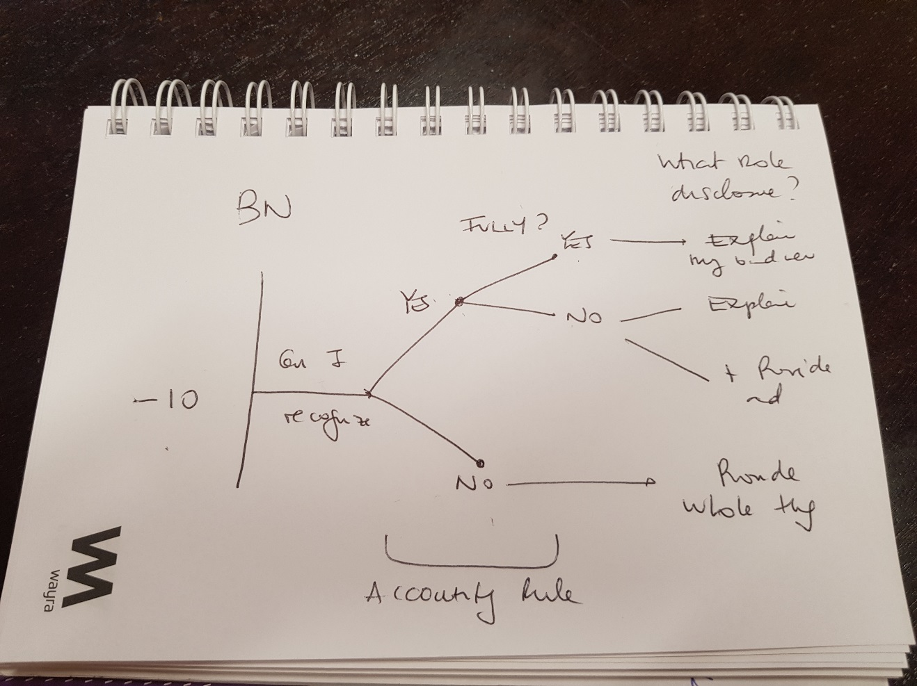

PLAN: before next meeting, send a short abstract with the storyline and hypothesis, and setting.

02/21/2020

I study whether narrative disclosure in annual report is conditionally conservative, i.e. timelier or concurrently sensitive in reflecting publicly available “bad news” than “good news”.

TONE = B1+B2*RET+B3*NEG+B4*RET*NEG+CONTROLS

For assets that are unconditionally conservative in financial statements such as R&D investment and social capital (trust), which are not allowed to be capitalized in balance sheet and therefore cannot be impaired in case of bad news nor revaluated in case of good news under US GAAP, firms can only communicate their related good and bad news in annual report through narrative disclosure. In this case, whether narrative conservatism is applied to these assets is not clear. Firms may voluntarily disclose bad news faster than good news because they choose to use more prudence in good news verification in order to avoid litigation, or may disclose both type of news with same timeliness because they want to provide neutral information, or may disclose good news faster than bad news due to managerial incentive to withhold bad news.

For assets that are conditionally conservative in financial statements such as PPE and other intangible assets, which are capitalized in financial statement and subject to impairment, firms are required to recognize incurred losses but are not allowed to recognize gains from revaluation under US GAPP. Therefore, firms can convey bad news through both numerical and narrative disclosure but good news only through narrative disclosure.

1. Narrative disclosure is more (less) timely in reflecting publicly available “bad news” than “good news” for assets that are unconditionally conservative in financial statement

TONE_RD = B1+B2*RET+B3*NEG+B4*RET*NEG+CONTROLS

1. Narrative disclosure is more (less) timely in reflecting publicly available “bad news” than “good news” for assets that are conditionally conservative in financial statement

TONE_PPE = B1+B2*RET+B3*NEG+B4*RET*NEG+CONTROLS

TONE_ITGB = B1+B2*RET+B3*NEG+B4*RET*NEG+CONTROLS

Not ITEM BUT POLICY

Explanatory narrative disclosure explains incurred gains and losses, and forward-looking narrative disclosure predicts future expected gains and losses. If explanatory narrative disclosure is consistent with numerical disclosure, then it should reflect bad news in a timelier manner than good news and vice versa.

1. Explanatory narrative disclosure is more (less) timely in reflecting publicly available “bad news” than “good news”

TONE_EXPL = B1 + B2*NEG + B3*RET + B4*RET*NEG

1. Forward-looking narrative disclosure is more (less) timely in reflecting publicly available “bad news” than “good news”

TONE_FLS = B1 + B2*NEG + B3*RET + B4*RET*NEG

In 10-K files, managerial discussion and analysis section is not audited while the notes to financial statements are audited. Auditors’ incentive to avoid litigation risk is very likely to drive narrative disclosure towards high level of conservatism.

1. Audited narrative disclosure is more timely in reflecting publicly available “bad news” than “good news”

TONE_NOTES = B1 + B2*NEG + B3*RET + B4*RET*NEG

1. Unaudited narrative disclosure is more (less) timely in reflecting publicly available “bad news” than “good news”

TONE_MDA = B1 + B2*NEG + B3*RET + B4*RET*NEG

10-Q (more timely) 8-K (most timely)

US GAAP and IFRS require firms to recognize impairment for most of asset items in financial statements when it is more likely than not that losses have been incurred under unfavorable events and circumstances, i.e. bad news. However, in some cases impairment recognition in financial statements cannot fully reflect losses incurred. For instance, when adverse conditions reduce the profit-generating ability of an internally developed intangible asset, no impairment can be recognized since R&D expenses cannot be capitalized under US GAAP, or only partial losses can be recognized since development expenses can be capitalized under IFRS. Another example is losses incurred in social capital, i.e. reputation, which cannot be recognized since it is an immeasurable intangible asset that does not appear in balance sheet. For those losses that cannot be (fully) recognized in financial statements, firms may provide further discussion or provisional estimation using textual disclosure in their reports. On the other hand, when facing favorable market conditions, i.e. good news, under US GAAP firms are not allowed to recognize gains in financial statements for fixed or intangible assets. Revaluation of fixed and intangible assets is permitted under IFRS but anecdotal evidence shows that upward recognition of asset is rare in practice (because revaluation requires references to an active market for the specific type of intangible, which is relatively uncommon). Therefore, firms may use textual disclosure in reports in order to communicate good news in a timely manner. Given the asymmetry treatment of good and bad news in accounting standards applied to numeric disclosure, I hypothesize that in order to achieve fair value accounting and communicate news in a timely and symmetric manner, firms will

1. Reflect news in their textual disclosure.

TONE = B1+B2*RET+CONTROLS; B2 POSITIVE AND SIGNIFICANT

1. Reflect
2. Provide more (less) informational (explanatory) discussion on good news comparing to discussion on bad news in textual disclosure, given the same magnitude of news impact. (Since the former cannot be recognized in numeric disclosure in case of good news comparing to bad news, firms put more emphasize on it in text disclosure)

INFO LENGTH = B1 + B2*NEG + B3*RET + B4*RET*NEG; B4 NEGATIVE AND SIGNIFICANT

EXPL LENGTH = B1 + B2*NEG + B3*RET + B4*RET*NEG; B4 POSITIVE AND SIGNIFICANT

BN: Which assets can be impaired, and which cannot?

GN: Which assets can be written up, and which cannot?

**US GAAP**

**BAD NEWS**

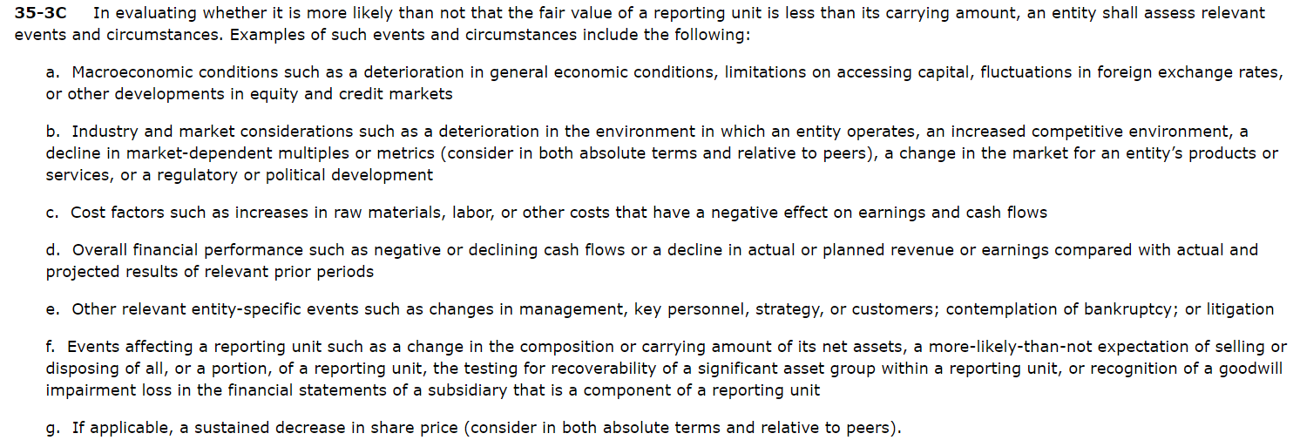

Total impairment: Intangibles (Goodwill and other) (more likely than not >50% that the fair value is less than its carrying value 35-3A), PPE (360-10-35-17: impair if carrying amount > sum of discounted cash flow generated by this asset), inventory, investment

~~Partial impairment~~: receivables (310-10-35-4-b)



Zero impairment: R&D, reputation

**Upward adjustment: fixed asset not allowed, intangible assets not allowed**

**IAS**

**BAD NEWS**

Total impairment: ?????????

Partial impairment: R&D (Development can be capitalized, and subject to annual impairment test)

Zero impairment: reputation

**Upward adjustment: fixed asset allowed, intangible assets allowed**

Which industries (cases) experience shock and how to identify the shock?

Oil industry: oil price (Bertrand and Mullainathan 2001)

How to disentangle explanatory and informational text from notes and managerial discussions? (Forward-looking statement? Li 2010 NO BECAUSE NO MATTER IT IS EX OR IN, THE LOSS/GAIN HAS ALREADY INCCURRED, HERE WE ARE NOT CONSIDERING THE ANTICIPATION OF LOSS/GAIN BUT RECOGNITION OF REALIZATION)

Footnote; MDA are they consistent with numerical disclosure? Footnote - explanatory，MDA - informational

到底narrative是用来加强numericals还是用来补充加入新的信息

News: oil prices, tariff (specific dates)

Number of dates between news and 8-K(10-Q)

NO INFORMATION content: STOP order, fire sells (due to mutual funds rebalancing portfolio)

Could use LDA to capture 8-K topic so we could know what content is being addressed

03/04/2020

1. Research question: is text disclosure more responsive to bad news than good news? in terms of
   1. Quantity of words devoted to discussing the news
   2. Tone: 1) Policy (assets item within notes) 2) Explanatory/forward-looking (notes v.s. MDA) 3) Audited (8K, 10-Q v.s. 10-K)
   3. Time lag between news and 8-K/10-Q issuance related to the news
2. Proxy for news
   1. Oil price (Bertrand and Mullainathan 2001)
      1. Pro: industry specific so that it is easy to associate a news to subsequent accounting treatment
      2. Con: applies only to the oil industry, so little external validity?
   2. ~~Firm-level political risk developed from conference call (Hassan et al. 2019)~~ (Endogenous)
      1. ~~Pro: firm-specific news is very accurate in identifying good/bad news~~
      2. ~~Con: (Endogeneity) the index is constructed from earnings call, which is a type of corporate disclosure mechanism. My RQ asks how timely corporate fillings reflect good/bad news, not how timely corporate fillings incorporate information from earnings call (the firms whose managers talk/perceive more about risk in earnings call may disclose bad news more timely in fillings).~~ 
         1. ~~Earning calls are preceded by fillings.~~
         2. ~~Earning calls and fillings have different disclosure thresholds.~~
   3. Economic Policy Uncertainty index (Baker et al. 2016)
      1. Pro: exogenous, constructed from news papers
      2. Con: macro level, difficult to identify which industries/firms are more/less affected by macro-level uncertainty.
   4. Akram – shortselling events as proxy for bad news and gov. subsidies as proxy for good news
   5. returns
3. Data collection: now I have written a program that downloads 8k and 10q, cleans the html tags, and can perform some basic statistical analysis on word basis.

Audit analytics: us WRDS, European own platform, AUDIT reports lenthy

Ramar and watts paper good will impairment;

News source may impact conservatism level

Given a risk exposure, build an expected level of conservatism, and then see how much the firm increase/decrease

03/30/2020

Done: raw data collection for 10-Qs

To do:

1. raw data collection for 8-Ks (short, non-sentimental; focus on topics)
2. improve doc_measures: 1) do term-weighting 2) algo: accurately divide 10-Q into different sections 3) refine tone
3. indecisive proxy: in main analysis use quarterly stock returns, and then perform an industry analysis using oil price, or case scenario study using other event news such as tariff changes.

Concept – property of text – measure (do a box graph)

04/13/2020

1. Roadmap
2. Main results – 10-Q: taking quarterly market-adjusted stock return as proxy for news (good news: positive return, bad news: negative return), see if quarterly report (10-Q) respond to news or not. (on average, 10-Q has a time lag between reporting period-end and filing date of 40 days.)
3. For 8-K, companies have four business days to file a Form 8-K for the events specified in the items in Sections 1-6 and 9. However, only few 8-Ks are filed within 4 days after quarter-end, which could potentially be related to the quarterly return news. Maybe to capture responsiveness of this more dynamic type of SEC filing, I should try monthly/daily return as proxy for news, to increase 8-K/return merge sample size and power.

Other events: <https://sec.report/Document/0001047469-99-029828/>

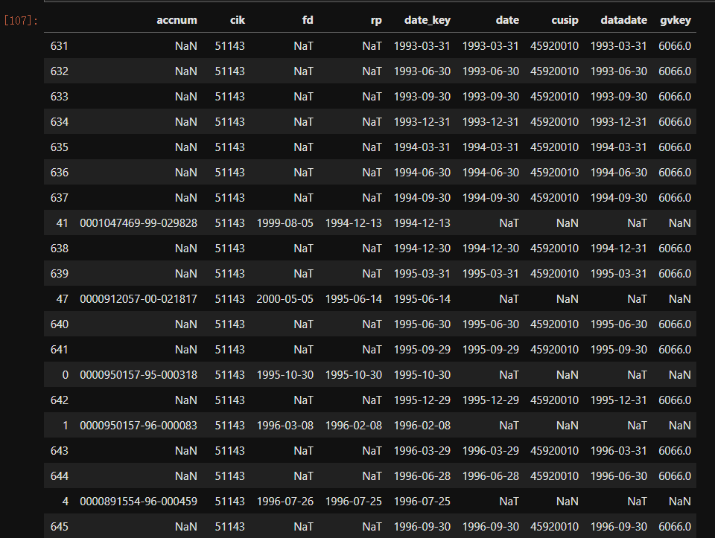

FROM 8-K RP TO MARKET DAILY ABNORMAL RETURNS/ OR FROM BIG DROP OF MARKET DAILY RETURNS TO 8-K

CONCEPTUAL FRAMEWORK

LEAD-LAG regression

1. Extreme cases in 10-Q: why some firms file 10-Qs years after?

<https://sec.report/Document/0001140361-07-012753/>

04/27/2020

1. Discuss D’Augusta et al. 2020 paper (blog)
2. roadmap
3. Should I use ABTONE in my study as a text measure, if I cannot replicate their main results?

DONE:

1. TLAG 99% deleted, results hold
2. TLAG inversed in regression to facilitate interpretation
3. ABTONE: Huang et al. 2014
   1. TONE regression (HUANG TABLE 1) Results can be replicated (see my TABLE 4), but TABLE 4 not reproducible
   2. Applying this abtone measure to my study, I found more exaggeration in narrative disclosure in response to bad news than good news.

TO-DO:

1. 8-K data
2. Read Ball and Shivakumar 2006
3. Check DA (mean should be 0!!!)
   1. Even if mean is 0, volatility is unusually high???? Anyway, not reproducible
4. Run Eq(3) with RET + NEG + RET*NEG? TABLE 5, basically it coincides with the results for ABTONE
5. Strategic delay in 10-Q filings? Auditors? Strategic bundling in 8-K filings? Why several 8-Ks per day?
   1. Read paper sent by Bea
6. voluntary 8-K? Does managers' discretion play a role in filing an 8-K or not? whether all 8-K items are compulsory? if yes do managers have discretion in the reporting time lag?
7. Conceptual framework
8. Tf-idf (LM 2011)
9. Adding readability as a text measure?
10. PAPER DRAFT
    1. Think about ABTONE results interpretation
    2. Timeliness is a property of information quality

05/12/2020

Done:

1. 8-K data
   1. Explain 8-K filing structure, cleaning, merging and matching process.
   2. 8-K item summary and main results.
2. Does managers' discretion play a role in filing an 8-K or not? Are all 8-K items compulsory?
   1. Among all items, only item 8.01 “other events” is voluntary
   2. Only item 7.01 and 8.01 are not subject to 4 business day reporting deadline
   3. Managerial discretion can still play a role within these 4 days limit

<https://www.sec.gov/rules/final/33-8400.htm>

1. Check DA (mean should be 0!!!)
   1. Even if mean is 0, volatility is unusually high???? Anyway, not reproducible
2. Run Eq(3) with RET + NEG + RET*NEG? TABLE 2 PANEL B, basically it coincides with the results for ABTONE

06/01/2020

To Do:

1. write tension: why narratives may not be conservative?
2. Strategic delay in 10-Q filings? Auditors (do not play a role because 10-Qs are usually unaudited)? Strategic bundling in 8-K filings? Why several 8-Ks per day? BEA papers
3. Read Ball and Shivakumar 2006
4. Dividing sections for 10-Q
5. Tf-idf (LM 2011)
6. Adding readability as a text measure?
7. (VALIDATION): whether NEWS and 8-K are talking about the same thing? Does 8-K contain new info itself?
8. Look into 8-K voluntary ‘other events?’
9. Relationship between reporting cons. And narrative cons? C_score

Writing:

1. Should we apply the Conceptual Framework properties in theoretical framework? Does our finding contradict the completeness, neutrality and timeliness requirement in CS? Timeliness definitely fits?????, but maybe completeness does not fit so well, and neutrality even contradicts with conservatism [I realized that and discussed in footnote 12]. I did not find a better way yet to make arguments about why conservatism in narrative should have the three characteristics (lengthier, more tone-consistent and timelier).
2. Title: asymmetric responsiveness of narrative disclosure/NC? If we use asymmetric responsiveness as our title, should we even mention/define narrative conservatism in the main body?
3. For the moment, we do not have tests to support that whether narrative disclosures with the three characteristics are more informative/useful/of higher quality or not. I will either drop this claim or design tests to prove this claim.
4. Numerical and narrative recognition (according to FASB Conceptual Framework, recognition does not only refer to numerical recognition, it also includes narrative recognition such as notes to financial statements), is narrative recognition also subject to the recognition criteria?
5. Narrative disclosure is tone-consistent or news-consistent? Which is the right word? What we want to say is that the tone of narrative disclosure matches with the sigh of market return, i.e., Positive tone-positive return, negative tone-negative return.
6. I want to mention/explain maybe only in one sentence where the name “reporting conservatism” comes from. Isn’t narrative disclosure a form of reporting as well?
7. ABTONE exaggeration

|  |  |
| --- | --- |
| GOOD NEWS + POSITIVE ABTONE | GOOD NEWS + NEGATIVE ABTONE |
| BAD NEWS + POSITIVE ABTONE | BAD NEWS + NEGATIVE ABTONE |

Emphasizing

Attenuation



Recognition/reporting/numerical conservatism?

More disclosure is better in analytical papers; L&M file size;

Thanks, some comments below!

1. Should we apply the Conceptual Framework properties in theoretical framework? Does our finding contradict the completeness, neutrality and timeliness requirement in CS? (I realized that neutrality contradicts conservatism and discussed that in footnote 12, but do the other two properties also contradict Conceptual Framework?). I did not find a better way yet to make arguments about why conservatism in narrative should have the three characteristics (lengthier, more tone-consistent and timelier).

I think here you can apply conceptual framework concepts, but not the full faithful representation definition, which implies neutrality. The idea is conservatism (instead of neutral) and asymmetric completeness, and timeliness. You can refer to the debate in conceptual frameworks for whether stewardship can be subsumed into a single information objective in general purpose financial statements or not (my Cascino et al. 2014, 2020 papers are on this and we cite this debate), and also, the extend to which conservatism is a desirable property of accounting information (here, work from Basu on the historical origins of conservatism is useful.)

2. Title: asymmetric responsiveness of narrative disclosure/NC? If we use asymmetric responsiveness as our title, should we even mention/define narrative conservatism in the main body?

I like Narrative Conservatism. It is catchy and says what the paper is about. I would keep it for now. If people hate it, we can think of whether to change it.

3. For the moment, we do not have tests to support that whether narrative disclosures with the three characteristics are more informative/useful/of higher quality or not. I will either drop this claim or design tests to prove this claim.

Ok, I think first we need to link narrative conservatism with earnings conservatism, to understand how the two interact, and then, we can try to think on whether narrative conservatism, in itself or in combination with earnings conservatism leads to better outcomes.

4. Numerical and narrative recognition (according to FASB Conceptual Framework, recognition does not only refer to numerical recognition, it also includes narrative recognition such as notes to financial statements), is narrative recognition also subject to the recognition criteria?

I agree that we need to be precise, perhaps we can discuss earnings conservatism? We need to think of a way to label things. The measures of conditional conservatism are based on earnings figures, and those of unconditional conservatism on balance-sheet numbers, so we can perhaps talk of earnings conservatism as a less ‘umbrella’ term? To discus.

5. Narrative disclosure is tone-consistent or news-consistent? Which is the right word? What we want to say is that the tone of narrative disclosure matches with the sigh of market return, i.e., Positive tone-positive return, negative tone-negative return.

Maybe “Narrative disclosure tone is news-consistent”? This captures what you say here, right?

6. I want to mention/explain maybe only in one sentence where the name “reporting conservatism” comes from. But I am not sure how to explain. Isn’t narrative disclosure a form of reporting as well?

This links to a number of above issues in how we label things and clearly separate different types. Here, you are looking at the whole 10-k, so that is footnotes plus other stuff, same with the 8-K, I think it is broader than the footnote conservatism, but still, footnotes would be considered ‘disclosure’ – maybe Juan has a different view.

7. ABTONE exaggeration explanation.

Maybe it is better to discuss simply abnormal tone rather than to call it ‘exaggeration’ which seems, in itself, an exaggeration

07/01/2020

To Do:

1. Read Ball and Shivakumar 2006
2. Alternative news proxy: Bao et al. 2019 short interest and insider purchase cohen et al.
   1. Does it reveals good/bad news?
   2. Does managers know the good/bad news
3. Dividing sections for 10-Q
4. Tf-idf (LM 2011)
5. Adding readability as a text measure?
6. (VALIDATION): whether NEWS and 8-K are talking about the same thing? Does 8-K contain new info itself?
   1. Would it be a problem if the market return change is responding to, or simultaneous to the 8-K filing? Which I think (from the data) is the case for most 8-Ks. Maybe not, because we only use market returns to classify good/bad news. The most important thing is that the disclosure SHOULD BE about the news.
   2. Revise algorithm to match nearest 8-K, not limited to matching to posterior 8-K days, but to the nearest 8-K days.
7. Look into 8-K voluntary items?
8. Relationship between reporting cons. And narrative cons? C_score
9. Incentive cross sectional tests: kothari et al 2008
   1. Litigation (more conservative)
   2. Option grant (more conservative)
   3. Stock issuance (less conservative)
10. What aspect contributes most to the impact of NC on capital financing costs?
11. Economic impact of NC solo?
12. Steps towards constructing a single measure of NC: calculate predicted value of TONE/NW/TLAG and see the overlap firms (the goal is to see if firms are conservative in all dimensions or only in some of them)

07/20/2020

To Do:

1. Alternative news proxy: Bao et al. 2019 short interest and insider purchase cohen et al.
2. Dividing sections for 10-Q
3. Tf-idf (LM 2011)
4. Adding readability as a text measure?
5. 8-K voluntary v.s. mandatory items?
6. Relationship between conditional and narrative cons? C_score
7. Incentive cross sectional tests: kothari et al 2008
   1. Option grant (more conservative)
   2. Litigation (more conservative)
   3. Stock issuance (less conservative)
8. What aspect contributes most to the impact of NC on capital financing costs?
9. Economic impact of NC solo?
10. Steps towards constructing a single measure of NC: calculate predicted value of TONE/NW/TLAG and see the overlap firms (the goal is to see if firms are conservative in all dimensions or only in some of them)

09/18/2020

1. Update new analyses in slides: T3PB readability, (T5, T6), T7PA + T7PB mandatory v.s. voluntary 8-K, T8 option grant)
   1. Update the figures: Figure 1 – 正方形框框，无颜色
   2. Figure 2 – 换成无色柱状图
2. Admin
   1. I will send this draft to evaluation committee by next Monday, and I will copy to you
   2. Should I send the drafts to EAA in next summer? its ddl is in Nov. 15th this year